PRAS General Ledger Setup
Manual (R12)
Accounting Segments and Flexfields

Client:
Shared Service Center
Finance and Accounting Department

Author:
Creation Date: January 8, 2015
Last Updated: January 8, 2015
Control Number and Version are marked by a Word Bookmark so that they can be easily reproduced in the header and footer of documents. When you change either of these values, be careful not to accidentally delete the bookmark. You can make bookmarks visible by selecting Tools->Options…View and checking the Bookmarks option in the Show region.

PROCEDURE DETAILS

Log in into Oracle Application 11i using your Username and Password

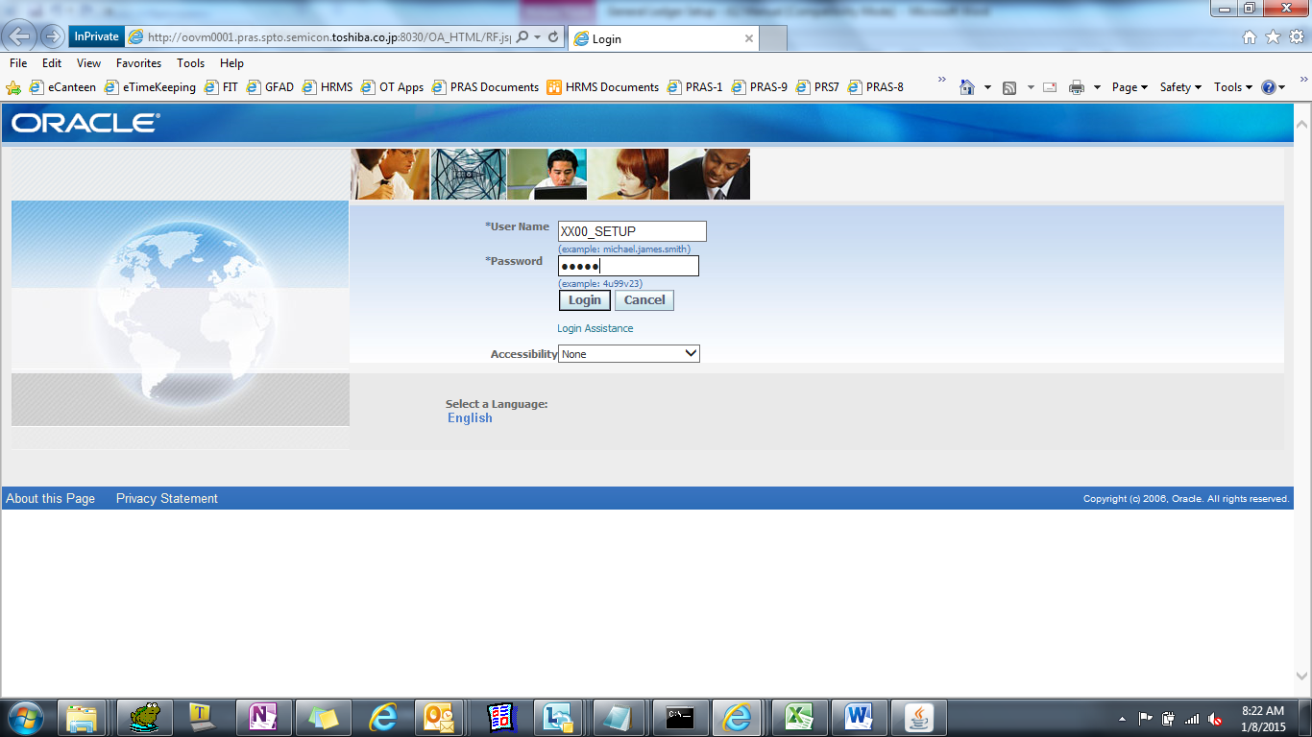

Select XXD4 TIP General Ledger Super User or TIP General Ledger Super User Responsibility 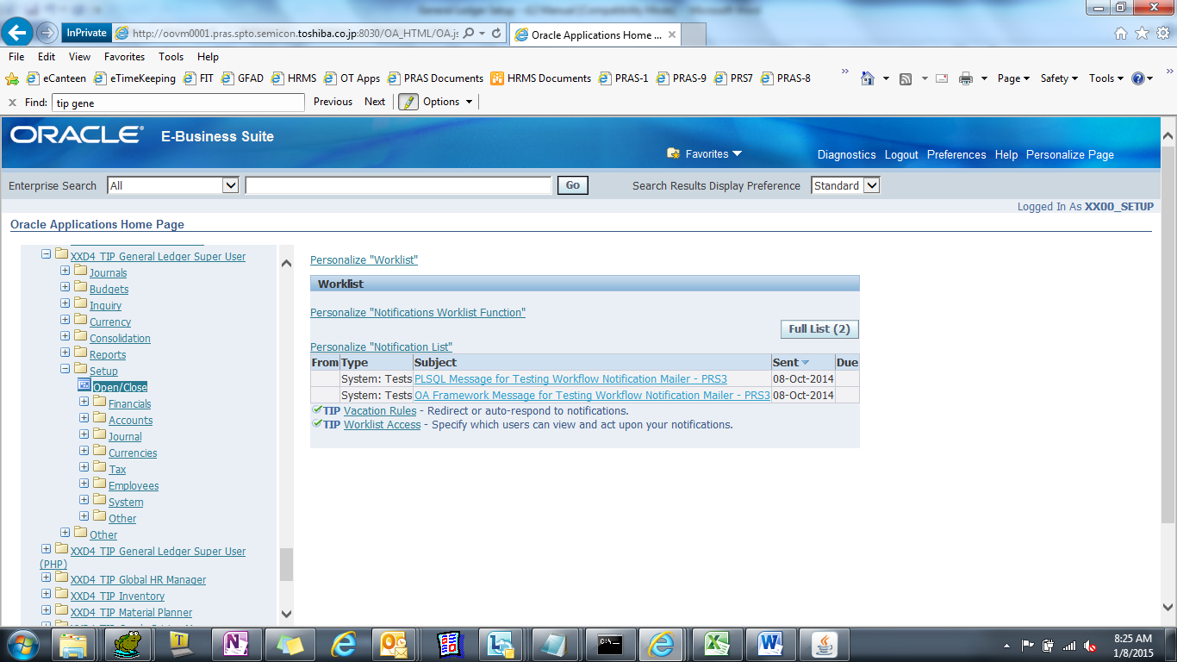

ACCOUNTING SEGMENTS

(N) Setup > Financials > Flexfields > Segments
- Find Record
i. Press F11
ii. Press Ctrl+F11

[T090593_TIP_AFF]
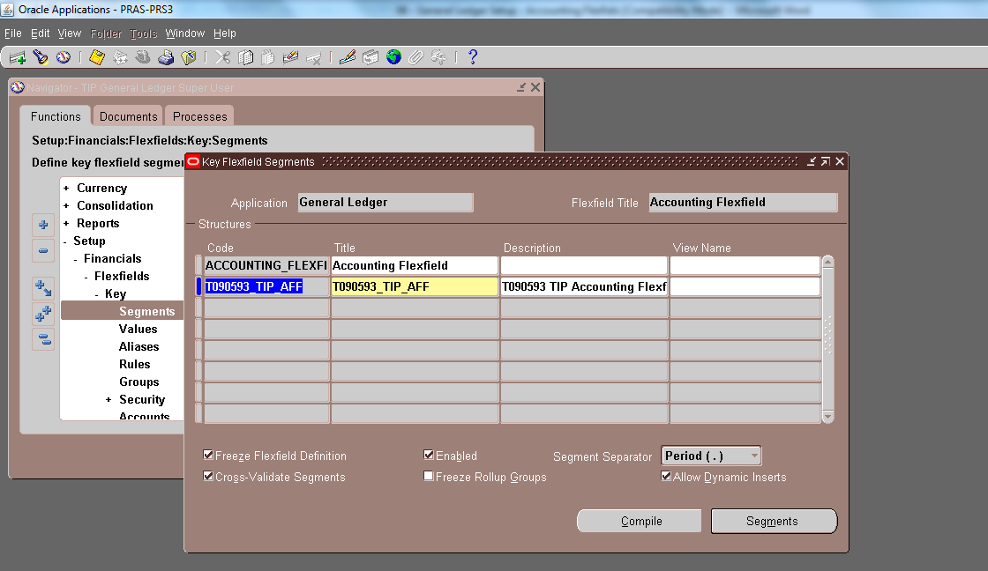

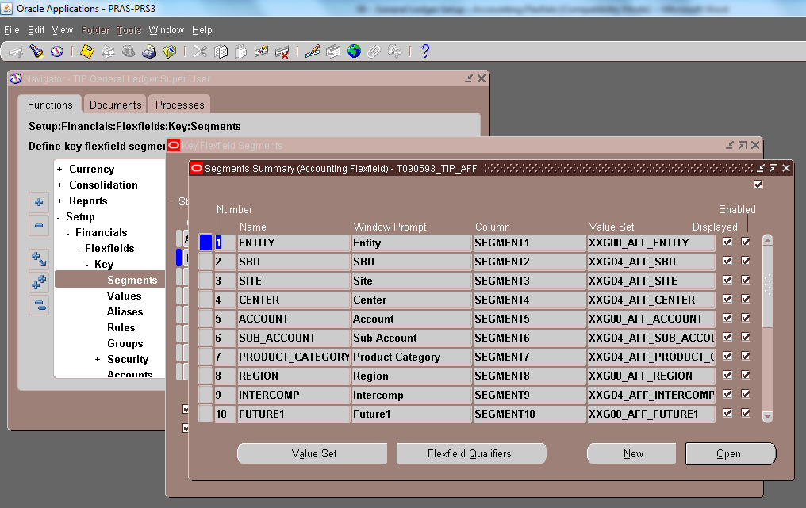
*Click Value Set for the value sets or see accounting flexfields screen shots on the next page.
FLEXFIELDS VALIDATION

(N) Setup > Financials > Flexfields > Validation > Values
- Choose Value Set, Name [XXG00_AFF_ENTITY]
- Click ‘Find’

SEGMENT1 : XXG00_AFF_ENTITY
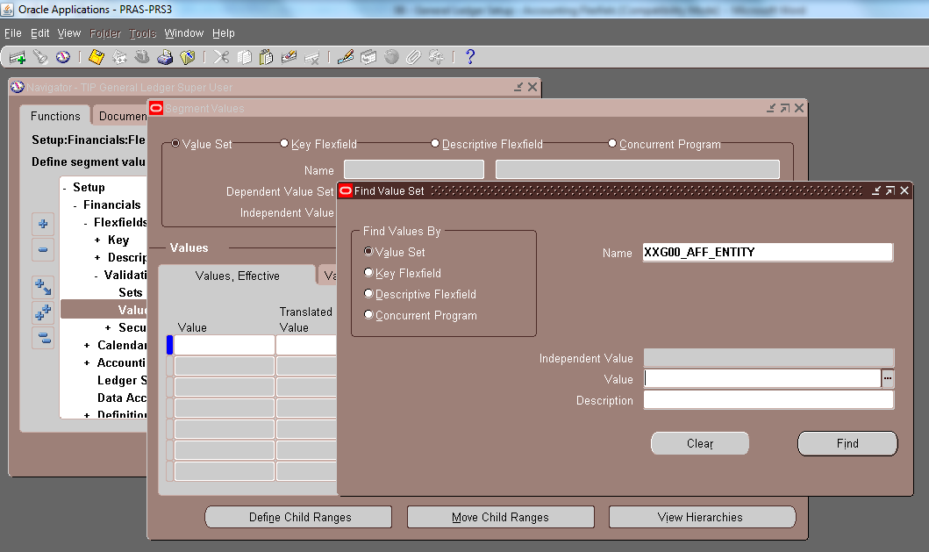

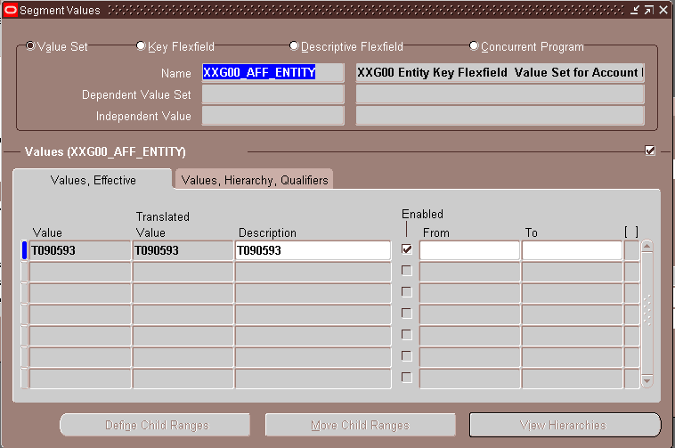
(N) Setup > Financials > Flexfields > Validation > Values
- Choose Value Set, Name [XXGD4_AFF_SITE]
- Click ‘Find’

SEGMENT2 : XXGD4_AFF_SITE
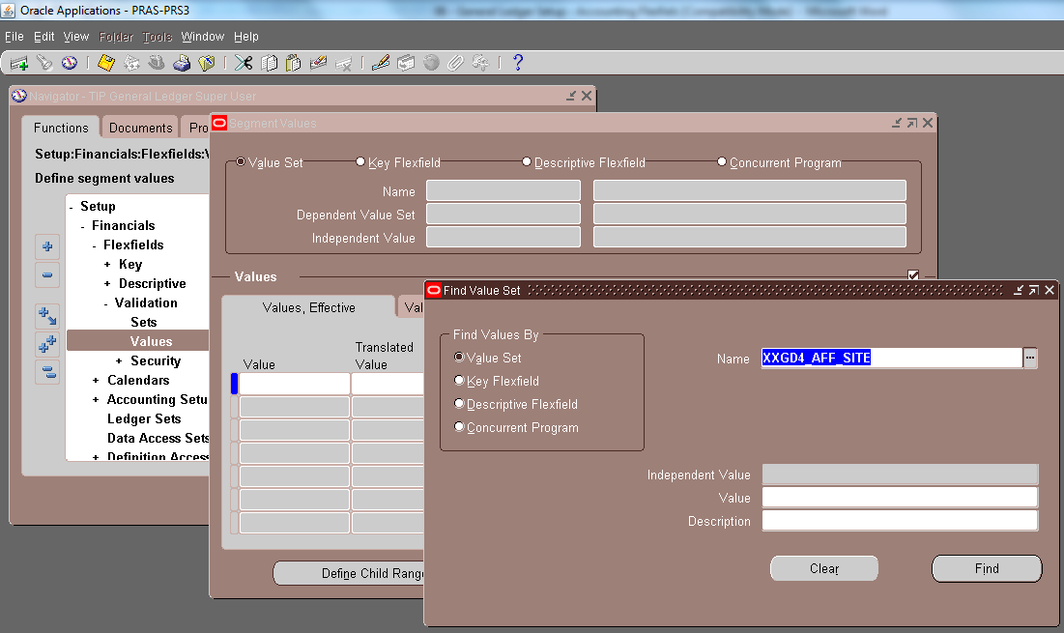

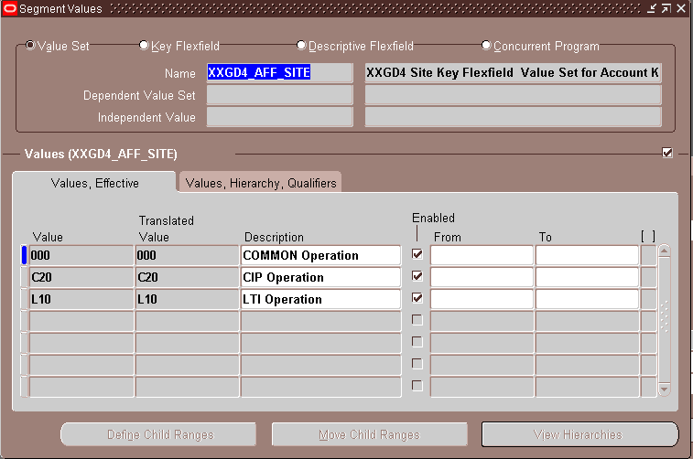

(N) Setup > Financials > Flexfields > Validation > Values
- Choose Value Set, Name [XXGD4_AFF_SBU]
- Click ‘Find’

SEGMENT3 : XXGD4_AFF_SBU
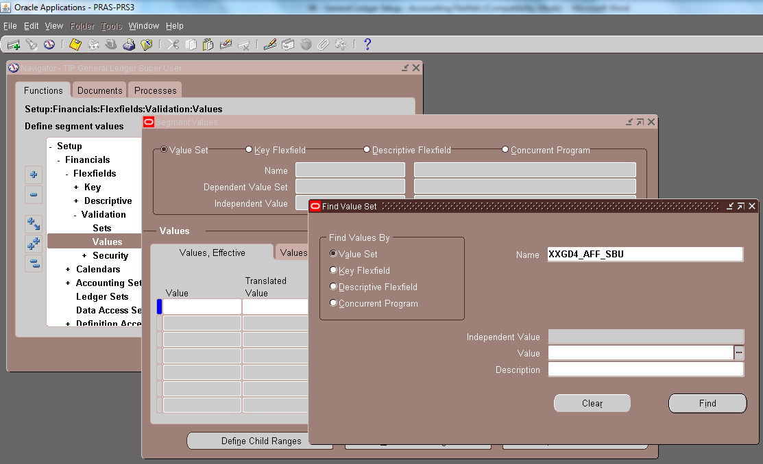

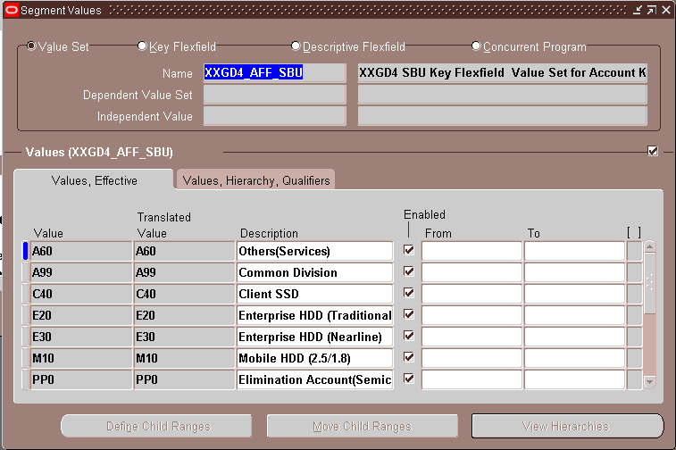

(N) Setup > Financials > Flexfields > Validation > Values
- Choose Value Set, Name [XXGD4_AFF_CENTER]
- Click ‘Find’

SEGMENT4 : XXGD4_AFF_CENTER
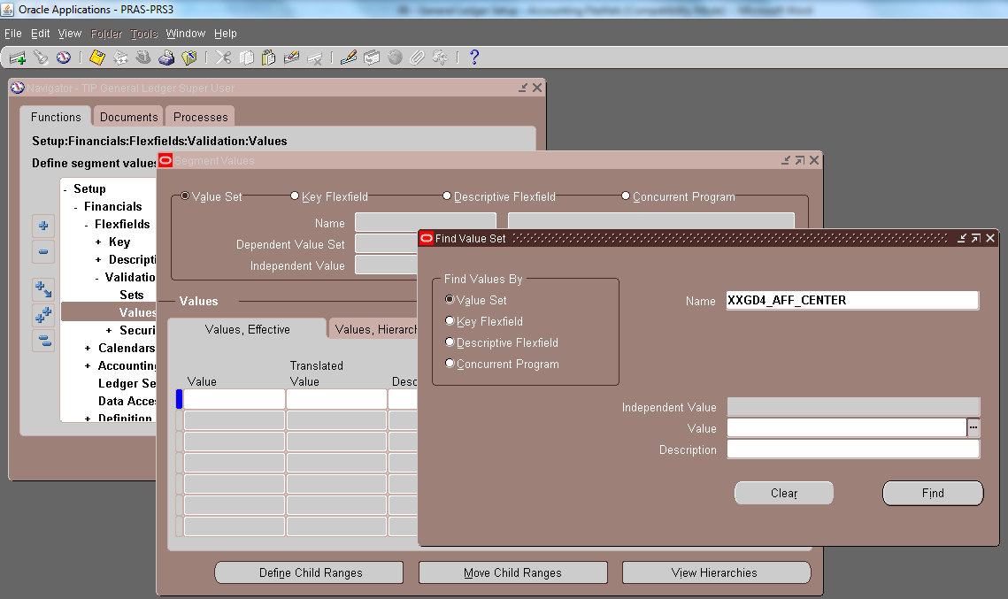

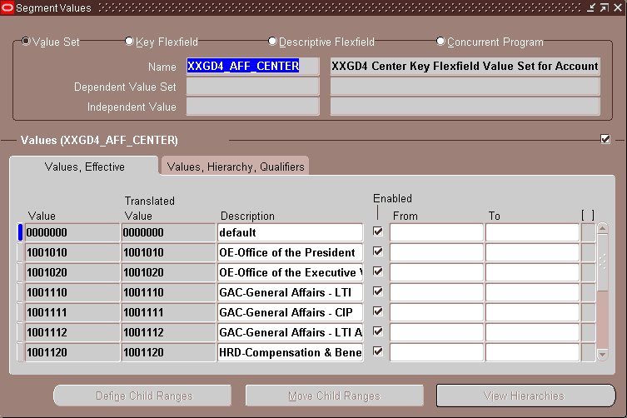

(N) Setup > Financials > Flexfields > Validation > Values
- Choose Value Set, Name [XXG00_AFF_ACCOUNT]
- Click ‘Find’

SEGMENT5 : XXG00_AFF_ACCOUNT
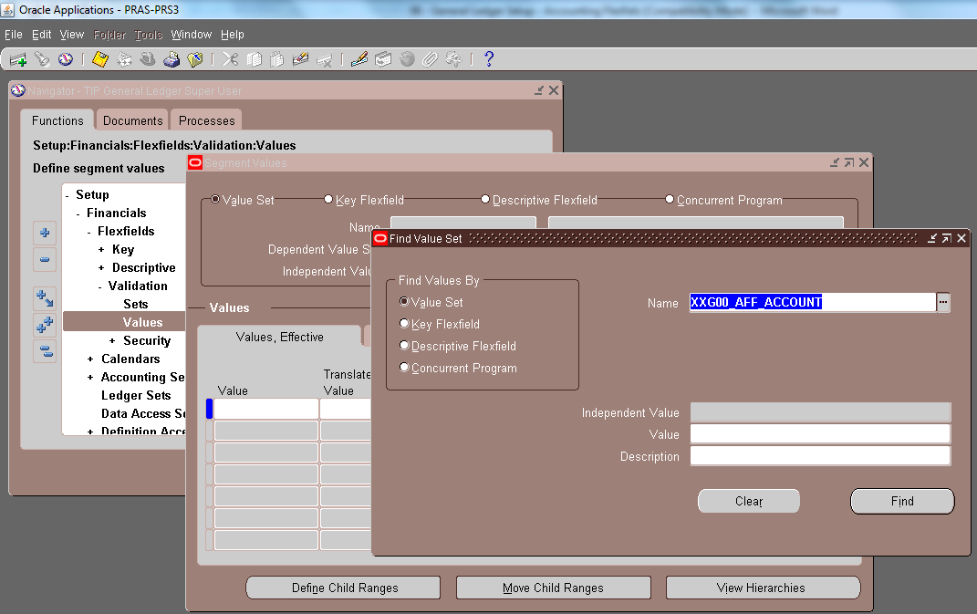

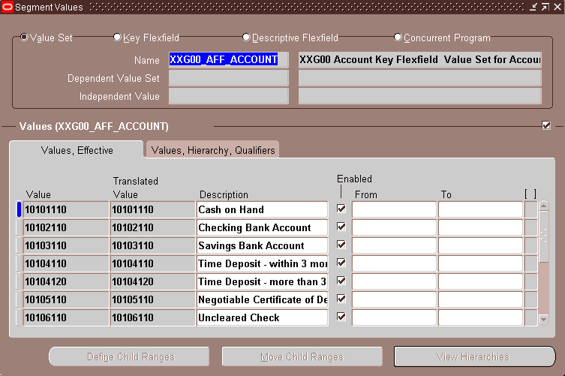
*Check Values, Hierarchy and Qualifiers Setup.
(N) Setup > Financials > Flexfields > Validation > Values
- Choose Value Set, Name [XXGD4_AFF_SUB_ACCOUNT]
- Click ‘Find’

SEGMENT6 : XXGD4_AFF_SUB_ACCOUNT
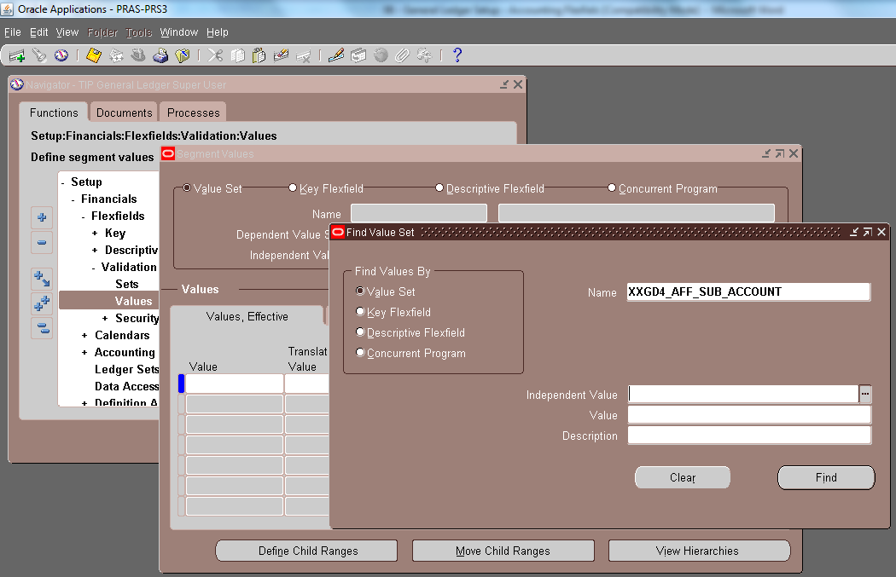

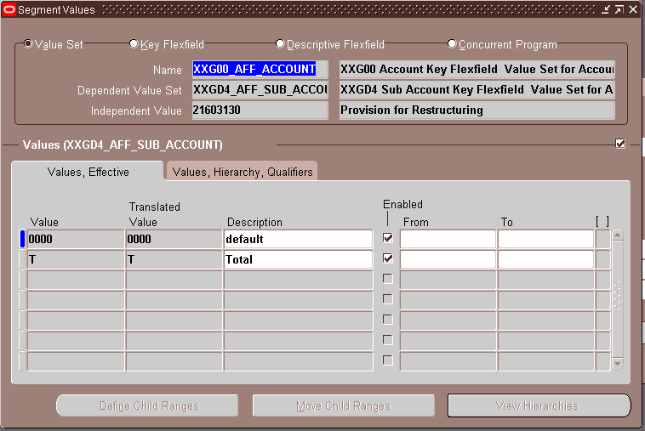
*Scroll down to check other subaccounts.
*Independent Values for specific Natural Accounts.
(N) Setup > Financials > Flexfields > Validation > Values
- Choose Value Set, Name [XXGD4_AFF_PRODUCT_CATEGORY]
- Click ‘Find’

SEGMENT7 : XXGD4_AFF_PRODUCT_CATEGORY
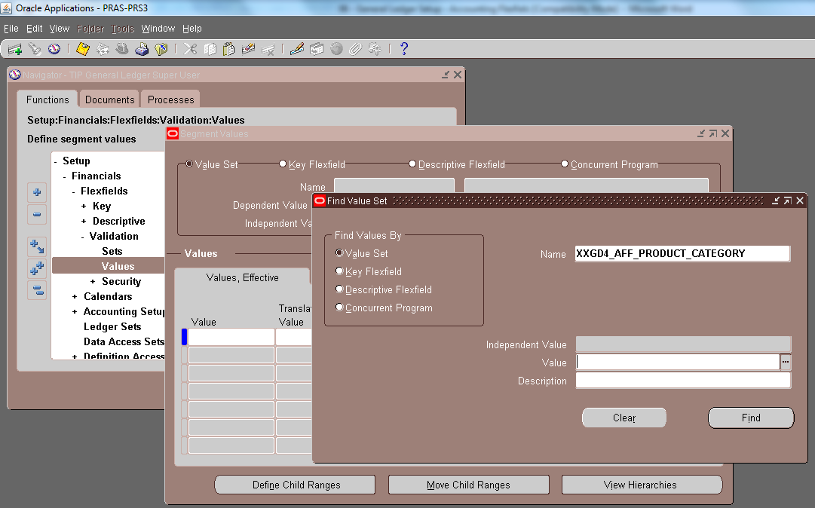

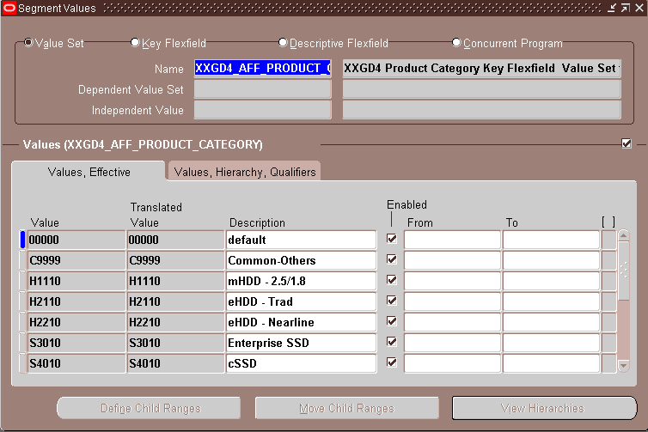

(N) Setup > Financials > Flexfields > Validation > Values
- Choose Value Set, Name [XXG00_AFF_REGION]
- Click ‘Find’

SEGMENT8 : XXG00_AFF_REGION
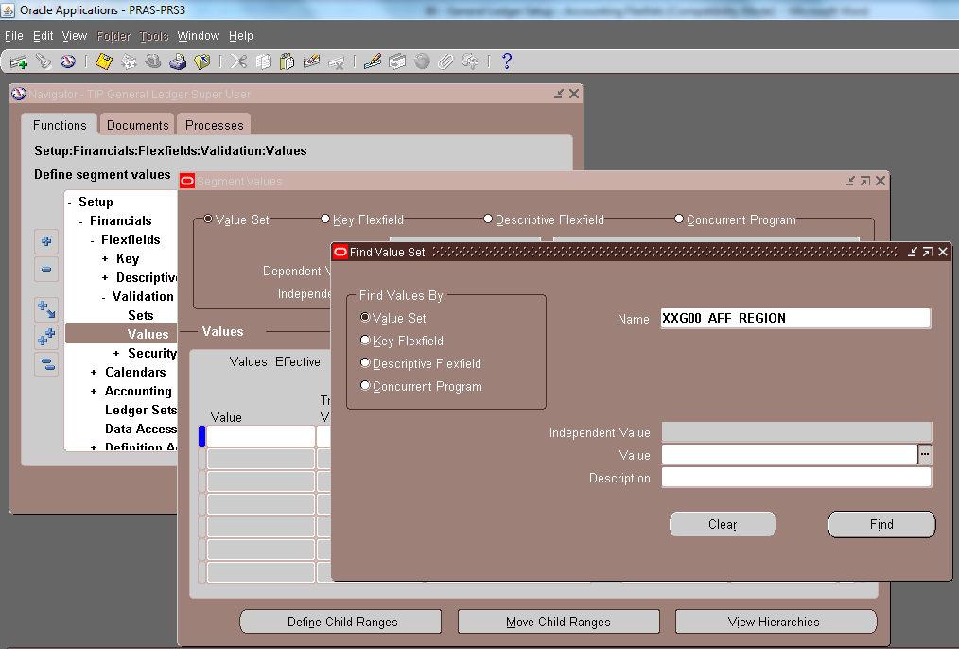

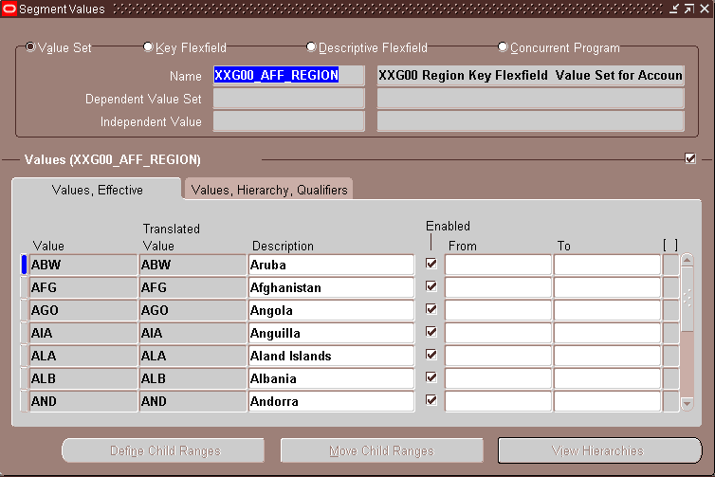

(N) Setup > Financials > Flexfields > Validation > Values
- Choose Value Set, Name [XXGD4_AFF_INTERCOMP]
- Click ‘Find’

SEGMENT9 : XXGD4_AFF_INTERCOMP
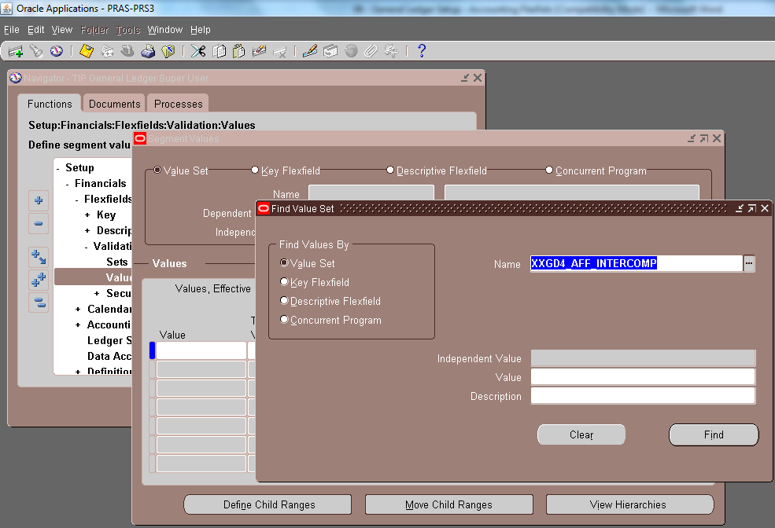

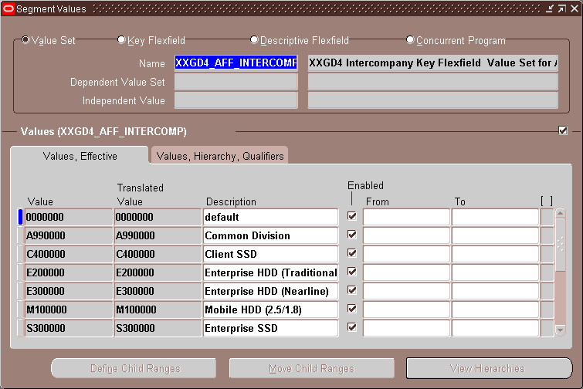

(N) Setup > Financials > Flexfields > Validation > Values
- Choose Value Set, Name [XXG00_AFF_FUTURE1]
- Click ‘Find’

SEGMENT10 : XXG00_AFF_FUTURE1
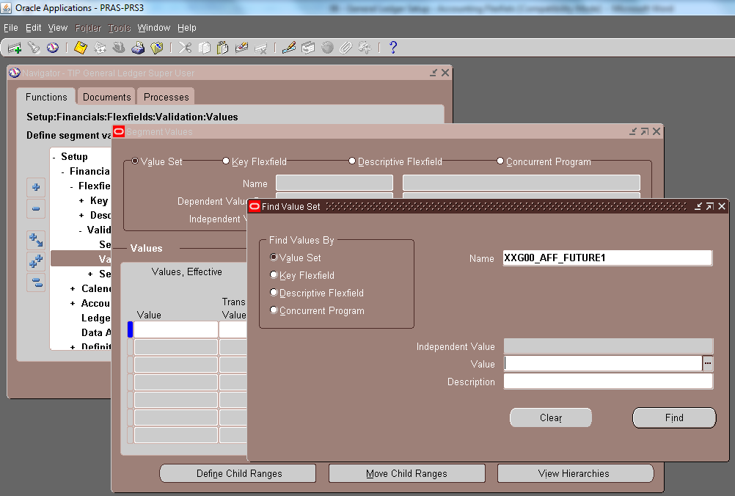

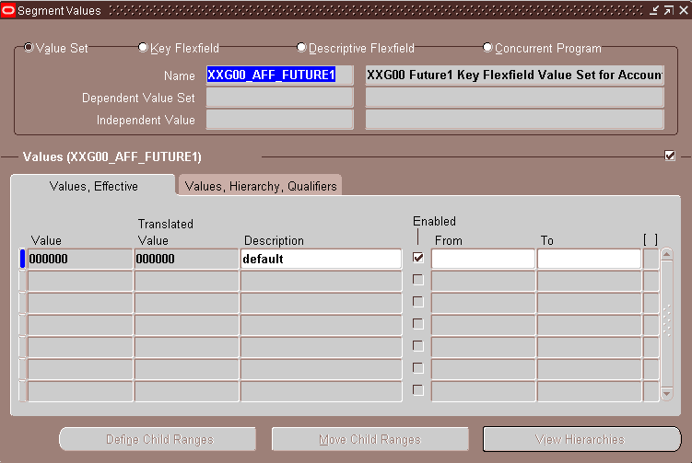

(N) Setup > Financials > Flexfields > Validation > Values
- Choose Value Set, Name [XXG00_AFF_FUTURE2]
- Click ‘Find’

SEGMENT9 : XXG00_AFF_FUTURE2
